

Kohler Jarod Groupe 3
Meister Nicolas 2021/2022
Parme Simon S2-A

Economic study of the project

cost/income, of the project

How much does it cost ?
The overall cost is around 12635€.

How much does it pay ?

The company's gross profit will be around 3065€.

cost calculation

elaboration of the costing of all the costs
we buy the skis for around 50% of the resale price, we add to that 25% of the price for the stock, and we add 5% for the delivery costs. The rest is only profit for the company.
-the purchase price of the skis is 7850€
-the cost of the stock will be around 4000 €,
-the cost of the delivery will be around 785 €,

forecast earnings
the website will pay us around €15700 for a stock of 70 skis. This is based on the overall income without counting the costs.

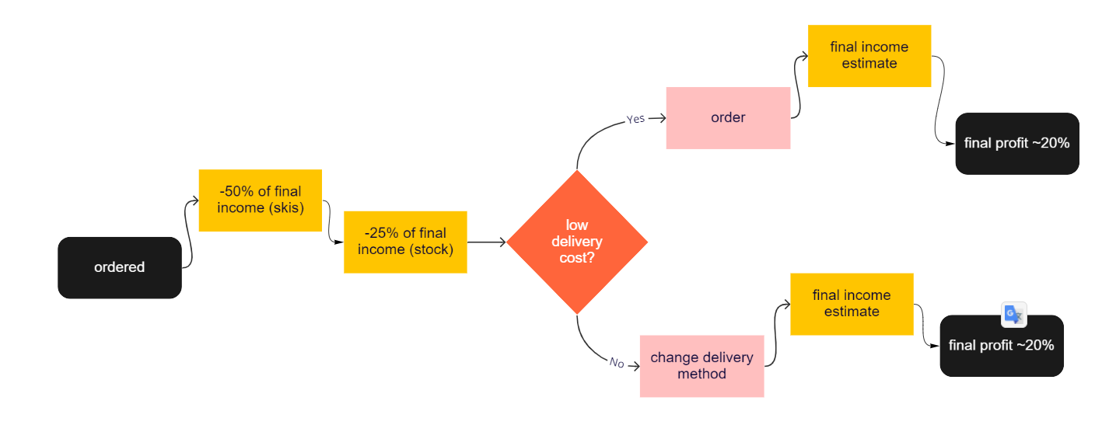
the causes of a variance in project costs

how to organize to manage all the hazards
On a stock of about 70 skis we get a profit of 3000€. This stock during the winter period runs out
every two week for 3 months, which makes :

3000 x 2 = 6000

we earns ~6000€ in one month in winter periods

6000 x 3 = 18000

in a winter period the overall costs of the site can be reimbursed 1 time and a half.

-in summer half a stock is sold out = 1500€ benefits

-in spring two stocks are sold out = 6000€ benefits

-in fall 3 stocks are sold out = 9000€ benefits

In 1 year the company generates 34500€ in profits

expenditure commitment schedule
The biggest expenses are made for the winter period with the Christmas holidays and the winter holidays. Each purchase of stock during school holidays is made when the first zone enters vacation and when the last one also enters it. And outside school holidays, the purchase of new stock is done at the beginning of the month and it is redone in the middle of the month

-For the autumn period a stock overhaul at the beginning of each month

-For the summer period the overhaul of the stock is done at the beginning of the season

-in spring the stock is made at the beginning of the season and is redone at the beginning of next month because some people are still skying at the beginning of spring

cash flow forecast
We especially plan to earn a lot of money at the end of the year because there are the holidays and it is especially at this time when the snow begins to arrive. It's from here that we start making a lot of money.

we will also earn some money towards the beginning of spring when the skiers will buy their new skis after practicing

And for finish we plan to make money during the fall period

